# SOLVING- **PRACTICE S5**

# Instructions

* For each item, you will be presented with a set of two pictures that are related to each other in the same way.
* Along with this pair, you’ll be given a third picture and four answer choices, which are also pictures.
* Of the four choices, choose the picture that would go in the empty box so that the two bottom pictures are related in the same way as the top two are related.

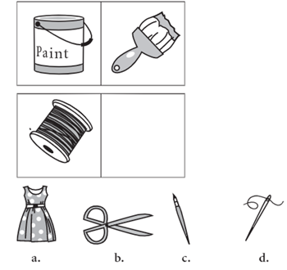

**Q1 –** Define the steps to solve this problem

|  |  |
| --- | --- |
| **Define**what is the problem, what is the expected work |  |
| **Find**a strategy | * **Step 1** * **Step 2** * **Step 3**   **Etc..** |
| **Implement**the strategy |  |
| **Review**, test, and if it does not work, change your strategy |  |

**Q2 –** Apply this strategy to solve the following 3 other problems

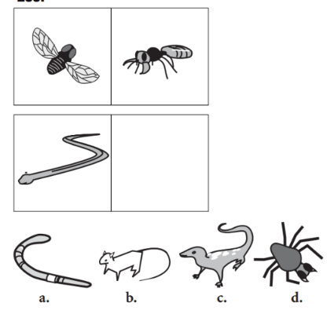

|  |  |
| --- | --- |
| **Implement**the same strategy |  |

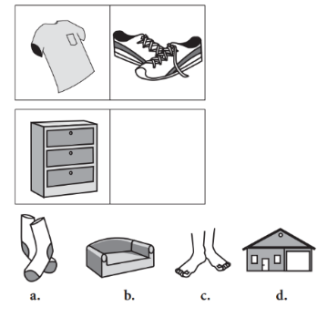

|  |  |
| --- | --- |
| **Implement**the same strategy |  |

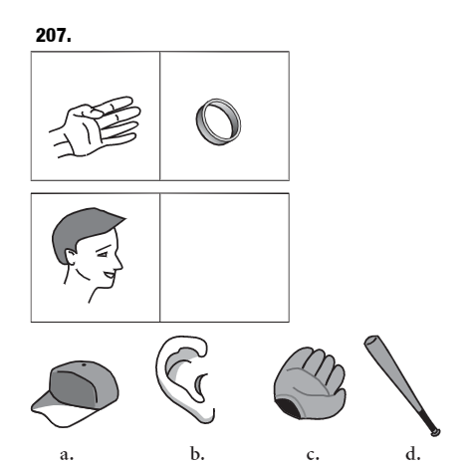

|  |  |
| --- | --- |
| **Implement**the same strategy |  |